JAMES COOK UNIVERSITY

SCHOOL OF ENGINEERING

EG4012

# THESIS REPORT: NON-DESTRUCTIVE THICKNESS TESTING USING A UAV COPTER DRONE

Christopher Kellie

Thesis submitted to the School of Engineering in partial fulfilment of the requirements for the degree of

Bachelor of Engineering with Honours

(Electrical Engineering)

May 8th 2015

# Statement of Access

I, the undersigned, author of this work, understand that James Cook University may make this thesis available for use within the University Library and, via the Australian Digital Theses network, for use elsewhere.

I understand that, as an unpublished work, a thesis has significant protection under the Copyright Act and I do not wish to place any further restriction on access to this work.

Signature:___________________

Date:__________________

# Declaration of Sources

I declare that this thesis is my own work and has not been submitted in any form for another degree or diploma at any university or other institution of tertiary education. Information derived from the published or unpublished work of others has been acknowledged in the text and a list of references is given.

Signature:___________________

Date:__________________

# Executive Summary

This thesis aims to explore the feasibility of amalgamating concepts from the relatively established Non-Destructive Evaluation (NDE) industry with the emerging UAV industry. Testing of uniform corrosion via thickness testing on large industrial vessels with simple shapes with a UAV should increase the spatial versatility of NDE, as well as reducing costs, safety hazards, time, and human involvement overall.

An unavailability of suitable craft necessitated a simulated dynamics approach, using software and recreated dynamics approach.

To keep this project within the realm of feasible time and cost, it has to amalgamate the main elements: the UAV, the ultrasonic transducer, and the stability-providing electromagnets. This was done with a custom designed assembly.

The UAV side was tested with software, to simulate the effect of the assembly on the craft, and the assembly side was tested to recreate the effect of the craft on the assembly, as well as its stand-alone efficacy.

# Acknowledgements

# Contents

1. Introduction 3

2. Literature Review 5

2.1 Non-Destructive Evaluation 5

2.1.1 Ultrasonics 5

2.1.2 Rovers 7

2.1.3 Corrosion 7

2.2 UAV TECHNOLOGY 8

2.2.1 System overview 8

2.2.2 Navigation 10

2.2.3 Collision avoidance and UAV preservation 16

2.2.4 Legal 16

2.2.5 Perching 16

2.3 Conclusion 18

2.3.1 Perching for larger craft 18

2.3.2 Weight capacity vs time of flight 18

3. Project Intent 19

3.1 Aim 19

3.2 Scope 19

4. Methodology 21

4.1 Assessing Project Needs 21

4.2 Design of Project and Assignment of success metrics 21

Testing the Project 21

Evaluation of Results 22

5. Project Management Plan 23

5.1 Timeline 23

6. Appendices 24

6.1 Risk Assessment 24

6.2 Gantt Chart 25

6.3 Reference List 26

# List of Figures

# List of Tables

# Introduction

Industrial vessels such as stacks have a high economic value set on their continuing integrity and operation. Routine problems, especially corrosion and weld integrity, pose a threat to this continuing integrity. Industries spend a lot of time and money in order to diagnose and prevent these issues from causing compromise of process or disaster, and ultimately to minimise their economic impact. Non Destructive Tests (NDT) such as ultrasonic thickness testing, ultrasonic diffraction flaw testing, radiographic flaw testing, among others, are used to diagnose trends of corrosion and weld integrity.[1] Corrosion flaws can be of a locally uniform type, or may come in many localised (macroscopic and microscopic) forms as well.[2]

Since such industrial structures are large, and often quite tall, methods have been developed to navigate, test, and tabulate data on these structures in an accurate and non-hazardous way. Generally this is accomplished with workers traversing the structures with scaffolding, elevated work platforms, or rope access.[3] This represents considerable limitations to the efficiency of NDT, mostly in terms of cost and time. An available alternative to this method involves using a rover vehicle with magnetic wheels to take these measurements, reducing labour and set up costs. Such a method does make strides; rovers can take a high density of measurements with accurate encoding, as their slow progression along the vessel allows for accurate position data.

Such rovers are generally tethered to a station that provides control, data processing, power, and irrigation where necessary, allowing for continuous operation. This continuous operation can be encoded in one of a few ways, depending on the transducer type, data of interest, and dimensional parameters of the test.[4]

However, testing with these vehicles comes at the cost of time, since the slow progression of the rovers is very time consuming for a comprehensive test. Such devices are also limited to smooth surfaces; obstructions on vessels will interrupt the continuity of the scanning process.

Emerging Unmanned Aerial Vehicle (UAV) technology has created affordable platforms for aerial imaging, especially in the fields of photography and imaging – both professional and amateur. The affordability of these contraptions has also lent itself to the field of amateur UAV development.

Typical consumer Vertical Take Off and Landing (VTOL) copter drones range wildly in price from around $50 to $10000, with commercial models going higher. Most range in between 400 and 3000 grams, depending primarily on the number of rotors. Unloaded flight time is usually at least 8 minutes, with varying payload capabilities of up to a kilogram.

The versatile nature of the UAV platform makes it a compelling means of hosting NDT tools. Such a highly manoeuvrable vehicle could conceivably not only increase the rate at which NDT is carried out, but also the possible places. A UAV that could fly up and perform NDT at an altitude of 100m, especially in a short time, augments many possibilities that are not currently possible or feasible.

# 2. Literature Review

## 2.1 Non-Destructive Evaluation

### 2.1.1 Ultrasonics

In the NDT realm, ultrasonic testing (UT) is one of the more prevalent methods of executing test. Its ubiquity can be attributed to its versatile nature. There are many types of ultrasonic testing methods, including acoustic resonance testing, electromagnetic acoustic transducer testing, laser ultrasonic testing, phased array ultrasonic testing, ultrasonic time of flight diffraction testing, Schlieren tests, and thermal or radiation force activity receiver type tests, among others[5]. These typically work at ranges of from 200 KHz up to 10 MHz. At such high frequencies, UT is able to detect flaws at a macroscopic level, provided they are not parallel to the direction of wave propagation. [1]

There are several ways to orient the transducers for normal incidence UT, though they will be some variation of one of two setups. The first is Direct or Through method, which involves two transducers (one acting as a transmitter and one as a receiver) on opposite sides of the media and the second is Pulse-Echo method, where the same transducer transmits a pulse into a medium and receives the corresponding echo shortly after. In the field, the Direct method is problematic to implement, so a Pulse-Echo setup is the only viable option.

UT is generally used for testing for macroscopic flaws such as pitting corrosion or procurement defects, but it is not uncommon for it to be used for testing the dimensional thickness of a material. Certain imaging methods that are intended for finding transverse flaws also include a fairly clear indication of medium boundaries.

Commonly established imaging methods for normal incidence UT include A-Scans, B-Scans, and C-Scans. A-Scans represent the reflection strength vs time at a single point (0-Dimension), indicating both discontinuities and boundaries of a single point scan. B-Scans represent a series of A-Scans encoded against 1-Dimensional movement. Typically, the Cartesian plane is reserved for 1-Dimensional translation (x), time (y), and the signal strength is plotted as a colour gradient. C-scans represent a planar (2-D) scan, where some amplitude metric is plotted as a colour gradient. Supplementary A-Scan data is available for each evaluation point. [6, 7]

These imaging methods are also suited to image data recovered from an array of transducers. Phased arrays consist of a series of ultrasonic transducers that can be activated in series or combination to recreate dimensional translation or use the interference to create an anisotropic vibration pattern.

An ultrasonic transducer consists of a housing, an active piezoelectric layer, a wear plate and a backing material layer (generally much thicker than the active piezoelectric layer. The properties of these layers are very important to the function of the transducer. All of these layers have a characteristic impedance Z that relates wave velocity and pressure:

$Z=\frac{P}{v}=ρ.c$ (2.1.1a)

Where P is particle pressure $v$ 
 is particle velocity  
ρ is the medium density  
c is the speed of sound in the medium

At the boundary between two media, both the particle pressure and particle pressure are continuous, else they would cease to be in contact. Due to this property, not all of the energy in a sonic wave will be transmitted between two media with different characteristic impedances. Some fraction of the incident energy will be reflected per the equation

$R=\frac{Z_{2}-Z_{1}}{Z_{2}+Z_{1}}$ (2.1.1b)

It is therefore important to match the media the wave is to travel through as best as possible. As the wave travels through the wear plate, coupling medium and testing medium and returns back, a large amount of the incident energy is capable of being dissipated. The wear plate will generally match the impedance of the active piezoelectric element. How well matched/damped to the active piezoelectric layer the backing layer is is an exchange of instrument sensitivity and penetrative power; a poorly matched backing layer will reflect the energy towards the testing medium, but a well matched backing element will increase the bandwidth and overall sensitivity of the transducer.

The coupling medium is an important aspect of the testing setup as well. In many circumstances, air would be a very convenient coupling medium, though its characteristic impedance is quite different to that of steel or piezoelectric, thus the transmission coefficient is very low between media. Irrigated water is a ubiquitous medium, though this proves a problem for a mobile platform. Other dry coupling media are available, such as Silverwing NDT’s rubber wheel.[8]

### 2.1.2 Rovers

Current Rover/crawler solutions are able to adhere to a steel vessel with magnetic wheels, and perform A, B, or C ultrasonic scans, depending on their encoder capabilities. Some of these appliances have a dry or wet coupling method. Wet coupling methods, such as an irrigated water method, will require a tether, sometimes referred to as an umbilical cord.[8]

### 2.1.3 Corrosion

Corrosion can happen in many ways. In the basic sense, an object can exhibit three kinds of behaviour with respect to corrosion:

* Immune behaviour, where the material is generally unaffected by neighbouring electrolytes.
* Passive behaviour, where initial corrosion occurs, but results in an insoluble protective film that greatly slows the rate of reaction.
* Active behaviour: a reaction occurs and produces a soluble, non-protective layer. Characterised by high material weight loss.

Corrosion is best categorised hierarchically, shown: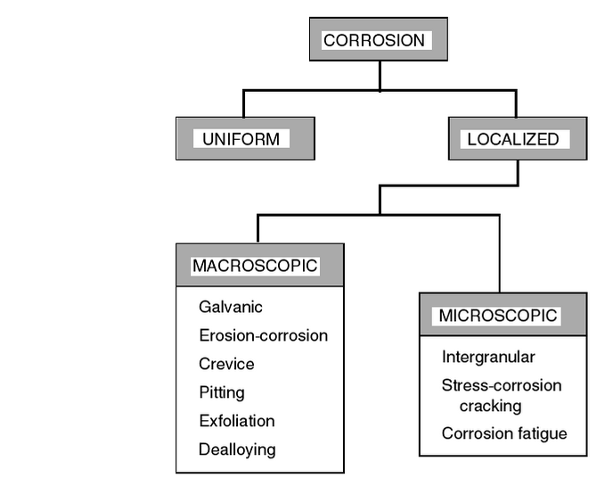

Figure 2.1.3a Corrosion Hierarchy[2]

Thickness testing will focus on diagnosing uniform corrosion. Though it is possible that if the quality of information is high enough, the craft may be able to test for certain macroscopic defects as well, such as pitting, or regions of dealloying.

## 2.2 UAV TECHNOLOGY

### 2.2.1 System overview

Multirotor copter are afforded their popularity by a few factors, including their versatility, low cost, lack of swashplate mechanism, relative simplicity to design, among other things. [9]

They consist of a frame, motors, rotors, speed controllers, IMU, control electronics or flight computer, CPU, and other peripherals such as a camera or radio link.

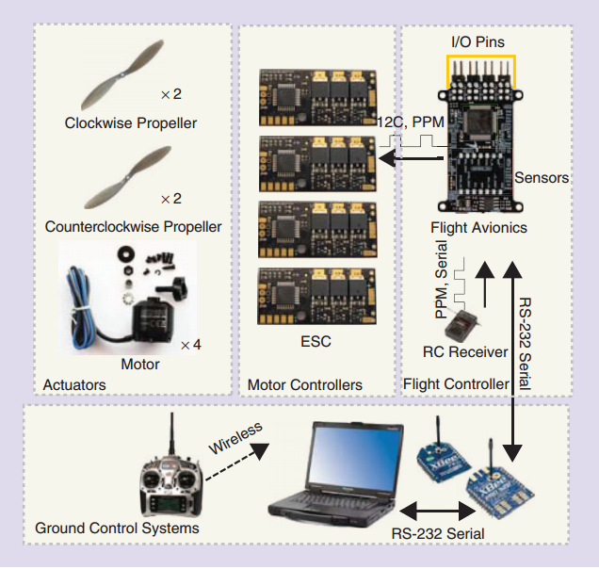

Figure 2.2.1a: Quadcopter Drone Components

There is a considerable DIY scene – 8 popular open source platforms exist that use popular processors.[9]

For a quadcopter in a steady condition, all of the rotors are at the same speed. To climb or descend, the rotors all speed up or slow down. To translate, the craft changes its pitch and roll such the vertical component is thrust is equal and opposite to gravity, and there is some horizontal component of acceleration. Pitch and roll are changed by slowing the motors on one side compared to the other side, in order to create an uneven moment on the craft. Of these motors two will be spinning clockwise, and two will be spinning counter clockwise. Motors diagonally opposite will be spinning the same direction. Yaw is changed by slowing one of these diagonal pairs in relation to the other opposite pair, thus causing a net moment about the vertical axis. In copter with more than 4 rotors, this becomes less straightforward, but the concept of altering the moments stays the same.[10]

In order to limit transient noise and steady state drift, the flight computers must implement a Partial-Integrator-Differentiator (PID) control system. Copter platforms do this with varying levels of automaticity.

### 2.2.2 Navigation

#### 2.2.2.1 GNSS

In order to orient themselves to the earth, objects can utilise what is known as a Global Navigation satellite (GNSS) system. These systems use simplex (unidirectional) UHF communication. They function by sending a time signal from several satellites with predictable orbits and using a receiver within atmospheric line of sight to use this information to deduce a latitude, longitude, altitude, and a synchronised clock value.

The most prevalent GNSS is GPS (Owned by the US military), though other systems exist. Russia owns and operate GLONASS, and China has the BeiDou system, with other systems in development by the EU and other countries. These all have varying degrees of accuracy, from within 8 metres (free access) down to 10cm (with licensed use). Australia has widespread use of GPS, which will be used in the project’s aircraft.

GPS technology in its current state does not provide suitable accuracy for the use of encoding the measurements taken. It does serve as a useful means of vague orientation against a vessel, though with CEP (50% of measurements within a radius of) values of 2.5m or greater on many units, this technology is limited to this application. Proposed GNSS systems may change this dynamic, however. It is for this reason that other complementary relative position and inertial measurement units are necessary in order to increase the accuracy to a meaningful value.

#### 2.2.2.2 IMU

The IMU is essential to the stable function of the aircraft. It provides attitude (pitch, roll, and yaw) information of the craft at a high rate in order for system to remain in a state of transient stability, and possibly to minimise its steady error, if the system has implemented the control systems for it. It will also be necessary for the purpose of orienting the craft against the vessel it is testing.[9]

Its function consists of MicroElectroMechanical Systems (MEMS) that make up an accelerometer and gyroscope, as well as a magnetometer unit. Collectively, these units provide a 3 axis reading of acceleration, a 3 axis reading of magnetic field, and a 3 axis reading of differential position. From the measurements of the compass and accelerometer, a bearing is obtained. The gyroscope is useful in the event that the other two sensors have some loss of signal or signal quality.

Each is with their respective drawbacks. Movement and vibration of the craft causes acceleration that may need to be filtered from the accelerometer data. An aircraft will use electrical motors that, without proper shielding, will affect the magnetic field that the magnetometer will detect, potentially causing loss of signal quality, and increasing signal processing requirements. The magnetic field may also be skewed by external factors such as inductive power loads or redirection of the earth’s magnetic field through a large structure. A gyroscope is generally immune to these sorts of effects since it only takes internal measurements, though this characteristic (Dead reckoning) comes at the cost of steady state bias. A regular calibration may need to be executed.

#### 2.2.2.3 Altimeter

Often a GPS is even less accurate in the altitude dimension than it is in latitude or longitude. Although bearing information can be supplemented to some degree by an IMU, this capability is not very accurate. It is highly beneficial to have a supplementary altimeter, and for the purposes of this project, necessary. Some stock crafts may come with some form of altimeter installed.

Barometer based altimeters are very common and quite cheap. Hobbyist models can cost about $10 and work up to 1km above ground level with an accuracy of about 30cm, which is not ideal, but is far better than what GPS can offer. Other limitations include fluctuation with temperature and humidity.

Detection and Ranging systems (such as RADAR and LIDAR) can also be used for these purposes, though they require a direct path to the ground and back. At lower ranges (<40m), LIDAR works at a higher accuracy than a barometer (a single digit centimetre accuracy), but this may not suit the heights of the project intends to cover. Sensors of this kind are also quite expensive, possibly costing more than half of the thesis budget. RADAR also has this shortcoming, though due to a lower SNR, has about the same accuracy as a barometer altimeter. RADAR often has large and powerful antennas as well.

#### 2.2.2.4 Ad-Hoc Local Positioning Systems

As well as sensors that measure static characteristics in order to discern bearing or position, there are a variety of ad-hoc sensor network local positioning systems that use characteristics relative to each other to discern bearing or position. Generally these systems are geared towards indoor environments where measuring GPS and other characteristics is troublesome. There are many of these available, though this review will limit the representation to three prominent, but different methods.

The ZigBee RSSI (Received Signal Strength Indicator) Indoor Local Positioning System [11] uses the inbuilt signal strength indicator to scope distance by relating reducing signal strength to distance. A ZigBee mesh will have an extensive range of these measurements relative to each other updating at some frequency, so a signal processing method such as Euclidian distance method, or a neural network algorithm needs to be implemented. The obvious disadvantage of this characteristic is that a powerful processor is needed to process all of the measurements, though this is common to most ad-hoc positioning systems. RSSI methods are also quite susceptible to multipath effects.

The Cricket Indoor Location System [12] uses a combination of RF and ultrasonic waves and uses the Time Difference of Arrival (TDOA) to discern the proximity of a node. However, this method is not particularly versatile, as the ultrasound wave is limited to line of sight applications in acoustically hospitable conditions. At ranges expected in this project, implementation of this system would be inappropriate.

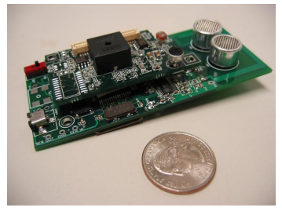

Figure 2.2.2.4a Cricket module

Ad-hoc Angle of Arrival (AoA) methods can also be used to triangulate and trilaterate an object. Put simply, the system uses an array of directional antennas in order to discern the angle to some node. If the AoA of 3 nodes with known positions is known, the location can be found through trigonometry. Disadvantages of this method include the complexity of the antenna arrays, and that the error of the angle measured actually depends on the angle itself, resulting in a nonlinear error. This would prove troublesome in an air to ground situation where the nodes are at similarly shallow angles.

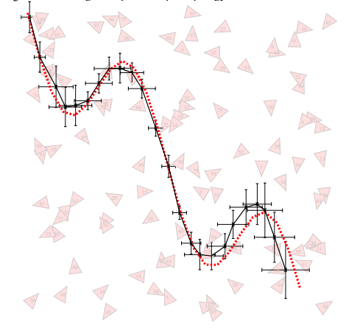

Figure 2.2.2.4b AoA Isotropic Tracking Map

Methods such as these are not particularly useful in a low duty cycle outdoor application, due to distance and power limitations, interference, lack of fastening points, and low economic feasibility.

#### 2.2.2.5 GNSS-Denied Environment SOlutions using sensor odometry

There are some solutions that do not make use of global or local systems in order to determine a location. These systems typically make use of pre-existing sensors on the craft, including the IMU and Detection/ Ranging systems. Some designs incorporate the use of one or more cameras as well.[13] Many of these systems work on a principle called SLAM (Simultaneous Location and Mapping), which has these sensors using feature detection to attempt to mitigate the error in a system with no absolute position information available.

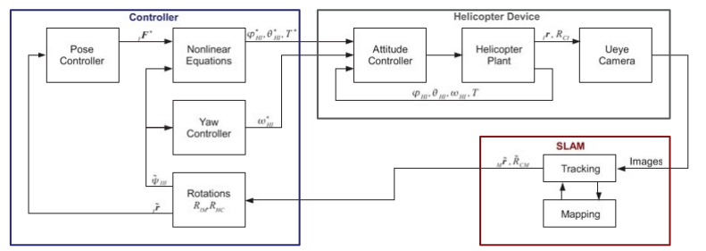

Figure 2.2.2.5a: mono vision slam integration block diag[13]

The SLAM system has the complex responsibility of fitting the tracking and the mapping information together in order to be effective. MIT’s *Stereo vision and laser odometry for autonomous helicopters in GPS-denied indoor environments* outlines how this is done by combining IMU and exteroceptive information and relaying this to a base station with more computational power. The base station calculates a global map, which the copter can compare its control loop states against.[14]

Figure 2.2.2.5b Stereo camera processing flowchart[14]

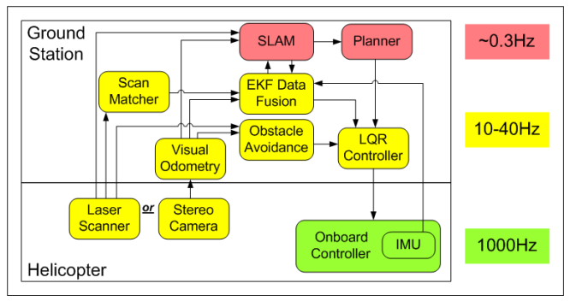

A design in other literature make use of a ZUPD (Zero Velocity Update), which calibrates the first integral of the IMU (velocity) to zero in conditions where it is known to be zero. A repeatable means of calibrating the velocity error reduces the velocity function to a type 1 system (finite steady state error), reducing the overall drift of the position information over time. The design (a shoe affixed IMU odometry system) proved to have about 2-3% error over 400m of walking.[15]

### 2.2.3 Collision avoidance and UAV preservation

Though LIDAR and ultrasonic distance sensors are not preferable solutions for altitude ranging, they are very desirable sensor platforms for short distance ranging. They are quite accurate at short ranges as well. These sensors can be used for both collision detection and to supplement telemetry.

Certain UAVs, such as the Parrot AR.Drone 2.0 incorporate the use of a hull or propeller guards in order to preserve the UAV in the result of a collision. If a collision occurs, the propellers will be preserved and the aircraft can be manoeuvred to a safe place if it is damaged.

### 2.2.4 Legal

The Civil Aviation Safety Authority (CASA) discerns the difference between Remotely Piloted Aircraft (RPA) and a model aircraft as: Any craft of any size used for commercial, government, or research purposes is classed as an RPA whereas model aircraft are flown for sport or recreation.

Flying an RPA for commercial reward requires a UAV controller’s certificate and an unmanned operator’s certificate for the business.

Without CASA approval and licensing, Aircraft cannot fly more than 400 feet above ground level (in controlled airspace), within 30 metres of buildings or vehicles without permission of the owner, outside of visual meteorological conditions(outside line of sight), within 5.5km of an airfield, or over populous areas such as beaches, heavily populated parks or in use sporting ovals.[16] This provides a limitation to the possibility of the project

### 2.2.5 Perching

There is some research and design perching technology (especially for a larger craft). The available resources did indicate a few novel concepts.

The first was not necessarily a perching mechanism, but does have merit in the testing that is to occur. UDC’s boiler inspection UAV (the MAGNEBOT) has a custom designed frame with four protruding arms with wheels on the end.[17] These wheels slot between grooves in a tube-wall commonly seen in boilers. This provides it with planar stability, leaving the craft with one dimensional degree of freedom – altitude. However, the innovation is currently only used for visual inspection, where the actual camera and electronics are offset from the wall by about 2 feet. A similar design could greatly increase the robustness of the encoding if the craft were able to use wheels to determine a change in position.

The second is a joint project between the University of Maryland’s Autonomous Vehicle Laboratory and Stanford’s Biomimetrics and Dexterous Manipulation Lab(BDML). The project has created a small quadcopter with a perching mechanism affixed. The mechanism uses a dry adhesive which incorporates biomimicry of gecko feet (using van der Waals forces) and a tendon and ratchet mechanism. Demonstrations show the contraption adhering to two horizontal surfaces: a floor and a ceiling, with the ability to continue to adhere at any angle between the two. [18]

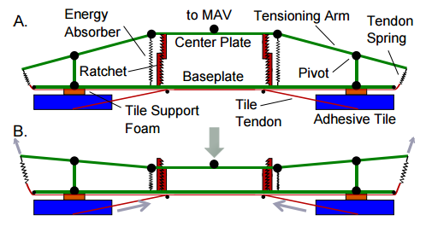

Figure 2.2.5a BDML Adhesive Mechanism

## 

### 2.2.6 Simulation – needs changing

Many flight and robotics simulators are available, with varying prices, intended applications, and ease of development. [19]

X-Planes

Webots - Open Dynamics Engine, VRML97 Environment, ease of development looks limited

SITL –needs looking into. May have retarded development

ROS

Gazebo

Peter Corke’s MATLAB Robotics toolbox – dunno if it has the dynamics for this application

Simmechanics – promising, guides available. Some learning required. But duh

## 2.3 Regression Analysis – needs more info and citations

Since the Hardware simulation has two simulated inputs, it is considered to be a multivariable system with two binomial outcomes and one ordinary outcome variable.

Logit or probit models could be used to model the outcome variable against the mutliple predictor values. However, using these methods in a multivariable context is not trivial. Thus the use of a linear(least squares or such) model to model a discrete situation such as this is probably suitable, accepting that the partially “mathematically nonsensical” results will require a sensible human interpretation.

## 2.4 Conclusion - edit

### 2.4.1 Perching for larger craft

The literature leaves something to be desired for the purposes of perching with a VTOL multicopter aircraft to a vertical surface. The concept of electropermanent magnets seem most suitable for the application of a perching VTOL multicopter, but are not well developed enough to be deployed in this project. Ordinary electromagnets will be used, despite their relatively high energy requirements, and weight.

### 2.4.2 Copter Drone mounted NDT transducer assembly

The literature has little to no relevant mention of a multicopter assembly that houses NDT transducers. A simple one will need to be created with simple, nonexpensive materials and methods such as wood carving or 3D printing (PLA or ABS).

### 2.4.3 Weight capacity vs time of flight

There is also very limited literature on how the payload weight affects the time of flight of a VTOL Copter Aircraft. This can be attributed to how it is very difficult to objectively quantify how characteristics of the craft affects its flight time.

# Project Intent – sections need editing

## 3.1 Aim

The ultimate objective of this thesis was to have a working design capable of autonomously taking thickness measurements within a minimal time frame with minimum human supervision. It is immediately obvious that such an objective is multifaceted and not without an expansive scope. It is for this reason that the project scope has been limited and prioritised by merit of:

* Application sequence (the order of actions that the finished product will execute)
* Perceived development opportunity
* Achievability

Thus, the precedence of the explored aspects of this thesis, in descending order, was:

To explore the feasibility of creating dimensional stability against a vertical surface with a VTOL copter drone with either a magnetic perching mechanism.

Another underlying issue of the VTOL copter drone is that the platform excels due to the minimalistic weights of the vehicles. The possibility and practicality of carrying all of the necessary appliances will be need to be investigated, in order to discern how the payload will compromise aspects of the craft such as manoeuvrability and flight time. This was done using a combination of simulation software and control algorithms.

## 3.2 Scope

There are a variety of sensor types. Alternative NDT methods and transducer types such as Ground Penetrating Radar and Acoustic resonance testing do exist, though unlike prevalent ultrasonic transducer types, these generally have bulky assemblies or unusual physical requirements making them hard to cater for in mobile applications, especially robotics. For this reason, the design was limited to the well-established thickness testing method of a piezoelectric transducer implemented as a pulse-echo A-Scan module.

The project had intended to use a pre-existing copter design, however due to availability and budget issues, the multicopter facet of the project was limited to simulation, and only the assembly was physically simulated.

The craft was limited in operation to testing the outside of the vessels using a pulse-echo testing method. In the physical hardware simulation of this project, this was simply represented as a flat plate of metal (holding the assumption that the vessel has a flat surface, or one with a large enough radius to make it effectively flat). It is possible that the sister project (Internal Inspection UAV) may facilitate NDE of insides of vessels at some point, but it was a concurrent development, so there was little room for integration.

Civil Aviation Safety Authority (CASA) regulations dictate that without proper approval, civilian unmanned aircraft must fly below 122 metres, only in clear weather during the day with a clear line of sight, and be at least 30m from buildings and vehicles(unless the owner has given permission). This was not an issue, as there was no physical testing involving an actual aircraft.

# Project Management Plan

## 4.1 Timeline

1. Topic Selection and Background Research 24/2 – 2/3
2. Literature Review and Research Skills 2/3 – 24/4
3. Proposal Write up 6/4 – 7/5
4. Assessing Project Needs 11/5 – 5/6
5. Design of Project And Success Metrics 6/6 – 7/8
6. Procurement and Testing, Final Report Drafting 8/8 – 28/8
7. Result Evaluation, Final Report drafting 29/8 – 25/9
8. Final Report draft , Seminar Abstract, And poster Submissions 9/10
9. Seminar Presentation 12/10 – 16/10
10. Final Report submission 29/10

# Methodology

## Design of Experiments

### Transducer Assembly Hardware Simulation

This experiment used:

1. A 3D printed assembly made of PLA(2 pieces)
2. Two steel plates(of thicknesses ~1.5mm and ~7mm) to simulate a wall the assembly would perch/fasten to
3. 2 vibration motors in order to simulate vibrations that a uav might introduce
4. 3 50N lifting electromagnets
5. A Benetech GM-100 5MHz Digital Ultrasonic Thickness Gauge
6. M20 Hex nuts to simulate the weight of the UAV
7. M20x300mm bolt to simulate the weight of the UAV
8. An Arduino Mega2560 to control the electronic components via UART
9. 5 logic level N-channel MOSFETS to switch the electronic components
10. A Standard ATX computer power supply to power the electrical components
11. A computer running PuTTY to interface with the Arduino Mega2560 over UART
12. Wood screws to hold the 3D printed pieces together

The 3D models were designed and rendered in OpenSCAD, and printed by Brendan Calvert. There was some dimensional contraction apparent, due to the nature of 3D printing, so these issues were rectified with hand tools, so that the electrical parts (3, 4, and 5) would fit snugly into the assembly. The 2 3D printed parts were fastened with woodscrews, and the weights were hung off of the assembly at a distance of __mm from the surface of the steel plate. The electrical parts were attached into a breadboard attached to the Mega2560, loaded with the code shown in abstract _____. This assembly was attached to the steel plates, where it was tested for

1. Its ability to adhere to the surface(Binary test)
2. Its ability to successfully couple the transducer to the surface(Binary test)
3. The recorded thickness(error test)

Against

1. Varied weight applied to the assembly

2. Varied Vibration intensity applied to the assembly

The weight is applied in intervals of ____grams up to _______, and the vibration was incremented in intervals of ______ up to ______.

The thickness and coupling information can be recorded from the GM100 module. The top-left symbol represents a successful coupling, and the thickness is displayed in mm, shown:

The overall design setup, shown:

Models and photos of the components of this experiment can be found in abstracts(s) _______

For some of the experiments, changes had to be made due to the chinesium incorporated in some of the experiments.

### Quadrotor Software Simulation

For the quadrotor side of the project, a software simulation was chosen due to budget (costs of and risks to UAV(s)/equipment). The intention of this part of the project was to gauge the effect of mounting the transducer assembly on the dynamics of a simple quadrotor.

This was done by simplifying the model of the attached assembly as a weight about its approximate centroid, in its expected position relative to the quadcopter. The hardware simulation module weighs approximately 320 grams with no vibration motors installed, so this weight will make the basis of the module mass in this software simulation. The module needs to be placed at

## Design of Metrics and Regression Analysis

## 3.3 Project Cost

|  |  |
| --- | --- |
| Item | Cost |
| GM100 Thickness Gauge | $116.90 |
| 3 x Electromagnets | $22.14 |
| 2 x Vibration Motors | $12.92 |
| Arduino Mega2560 | $20.20 |
| PLA filament – approx.150g | $4.35 |
| 10 x MOSFETS | $5.89 |
| 20 x M20 Nuts – Simulated Weights | $19.50 |
| M20 x 300 Bolt – Simulated Weights | $13.90 |
| Breadboard | $1.02 |
| ATX power supply | $0 |
| Steel Plates – Simulated surface | $0 |
| 9 x 8Gx25mm wood screws | $0 |
|  |  |
| Total | $216.82 |

## Evaluation of Results

The evaluation of the results following the tests is also necessary for future development.

# Results

# Discussion

# Conclusion

# 

# Reference List

[1] T. Nelligan, "Ultrasonic NDT," *Quality,* vol. 30, p. 24, 1991.

[2] J. R. Davis, *Corrosion : Understanding the Basics*. Materials Park, OH, USA: A S M International, 2000.

[3] "Best Practice For The Procurement And Conduct Of Non-Destructive Testing," in *Manual Ultrasonic Inspection*, ed. United Kingdom: Health and Safety Executive - Gas And Process Safety Technology Division, 2000.

[4] J. Cullerne, "Ultrasonic Imaging," in *The Penguin dictionary of physics*, ed London, United Kingdom: Penguin, 2009.

[5] J. P. Woodcock and A. Hospital Physicists, *Ultrasonics* vol. 1. Bristol: Hilger [for] the Hospital Physicists' Association, 1979.

[6] T. Nelligan. (24/4/2015). *An Introduction to Ultrasonic Flaw Detection*. Available: <http://www.olympus-ims.com/en/applications-and-solutions/introductory-ultrasonics/introduction-flaw-detection/>

[7] (2015, 24/4/2015). *Combined Image Formats*. Available: <http://www.olympus-ims.com/en/ndt-tutorials/instrumententation/combined/>

[8] "Scorpion remote access tank shell inspection | Ultrasonic Crawler," ed. Online: Silverwing NDT, 2015.

[9] L. Hyon, P. Jaemann, L. Daewon, and H. J. Kim, "Build Your Own Quadrotor: Open-Source Projects on Unmanned Aerial Vehicles," *Robotics & Automation Magazine, IEEE,* vol. 19, pp. 33-45, 2012.

[10] T. Luukkonen, "Modelling and control of quadcopter," *Independent research project in applied mathematics, Espoo,* 2011.

[11] S. Tadakamadla and B. Oelmann, "Indoor local positioning system for ZigBee, based on RSSI," 2006.

[12] N. B. Priyantha, "The cricket indoor location system," Massachusetts Institute of Technology, 2005.

[13] S. Weiss, D. Scaramuzza, and R. Siegwart, "Monocular‐SLAM–based navigation for autonomous micro helicopters in GPS‐denied environments," *Journal of Field Robotics,* vol. 28, pp. 854-874, 2011.

[14] M. Achtelik, A. Bachrach, R. He, S. Prentice, and N. Roy, "Stereo vision and laser odometry for autonomous helicopters in GPS-denied indoor environments," in *SPIE Defense, Security, and Sensing*, 2009, pp. 733219-733219-10.

[15] L. Ojeda and J. Borenstein, "Personal dead-reckoning system for GPS-denied environments," in *Safety, Security and Rescue Robotics, 2007. SSRR 2007. IEEE International Workshop on*, 2007, pp. 1-6.

[16] *Model aircraft and RPA,* C. A. S. Authority, 2014.

[17] J. S. Cavote, "Drones Promise Faster, Easier Inspection of Boilers, Stacks, Towers, and More - POWER Magazine," in *PowerMag*, ed. Online: PowerMag, 2014.

[18] E. W. Hawkes, D. L. Christensen, E. V. Eason, M. A. Estrada, M. Heverly, E. Hilgemann*, et al.*, "Dynamic surface grasping with directional adhesion," in *Intelligent Robots and Systems (IROS), 2013 IEEE/RSJ International Conference on*, 2013, pp. 5487-5493.

[19] J. Craighead, R. Murphy, J. Burke, and B. Goldiez, "A survey of commercial & open source unmanned vehicle simulators," in *Robotics and Automation, 2007 IEEE International Conference on*, 2007, pp. 852-857.

# Appendices

## 9.1 Risk Assessment

|  |  |  |  |
| --- | --- | --- | --- |
|  |  |  |  |

**Name of Test:**  Procuring and Testing design assembly on quadcopter drone

|  |  |  |  |  |  |  |  |
| --- | --- | --- | --- | --- | --- | --- | --- |
| **Purpose:** Thesis design testing | | | | | | | |
| **Operator:** | | | | **Duration:** 2 hours | | | |
| **SDS Attached:** | | No | | No **x** | | N/A | |
| **Major Hazard Types:** (Tick at least one) | | | | | | | |
| Chemical | | | | Mechanical **x** | | | |
| Electrical | | | | Thermal **x** | | | |
| Environmental | | | | Other: | | | |
| **SUMMARY OF RISKS** | | | | | | | |
| **Specific Task/Activity** | **Potential Hazards/Consequences** | | **Assessed Risk** | | **Risk Control Measures** | | **Reassessed Risk** |
| Flying Copter drone | Collision of large, expensive drone with human or environment | | High | | Only CASA registered pilots may fly the expensive drones. Safety glasses are to be worn when in close proximity | | Medium |
| Operating or servicing Copter drone | Fire as a result of Copter battery failure | | Medium | | Disconnect batteries where necessary | | Low |
| Soldering or 3D printing | Burns | | Medium | | Safety glasses, General caution when handling hot solder or plastic | | Medium-Low |

|  |  |  |  |  |  |  |
| --- | --- | --- | --- | --- | --- | --- |
|  |  | Consequence | | | | |
|  |  | Near hit, no injury. No $ lost or damage | First Aid treatment required for a minor injury Property damaged but can still operate | Medical treatment OR lost time injury.  Property damaged but can be fixed immediately | Serious injury requiring admission to hospital OR permanent disabling injury. Notifiable to regulatory Authority. Equipment damaged | Fatality, maximum high level headline exposure and loss of credibility. Equipment damaged/destroyed |
| Likelihood |  | Insignificant | Minor | Moderate | Major | Severe |
| It is expected to occur in most circumstances e.g. Daily | Almost certain | Medium | High | Extreme | Extreme | Extreme |
| Will probably occur in most circumstances.  e.g. weekly | Likely | Medium | Medium | High | Extreme | Extreme |
| Might occur at some time e.g. Annually | Possible | Low | Medium | Medium | High | Extreme |
| Probably won’t, but could occur at some time. e.g. once every 5 years | Unlikely | Low | Medium | Medium | Medium | High |
| May occur in exceptional circumstances. | Rare | Low | Low | Low | Medium | Medium |

## Gantt Chart